Weekly Construction Progress Report – Week 16
Harrow Bay Offshore Wind · 13 Apr – 19 Apr 2026
Elena Márquez · 20 April 2026 · HB-PM-RPT-2026-W16

1. Summary
1 monopile (HB-A03) was installed this week, bringing the total to 3 of 40. The foundation campaign is 1 pile ahead of the Rev 2 baseline. Waiting on weather amounted to 31 hours.
Area | Status | Comment
Overall schedule | Green | 3/40 monopiles vs. 2 planned
Foundations | Green | TPs installed: 2
Offshore substation | Green | Fabrication / load-out
Cables | Green | Manufacturing on schedule
HSE | Green | No incidents

2. Progress
Metric | This week | Cumulative | Plan (cum.) | Variance
Monopiles installed | 1 | 3 | 2 | +1
Transition pieces installed | 1 | 2 | – | –
Waiting on weather (h) | 31 | 37 | – | –
Persons on board (avg.) | 101 | – | – | –
Man-hours MV Sea Atlas | 8,257 | 16,673 | – | –
Lost time injuries | 0 | 0 | 0 | 0
Recordable injuries | 0 | 0 | – | –
Near misses reported | 0 | 0 | – | –
HSE observation cards | 22 | – | – | –

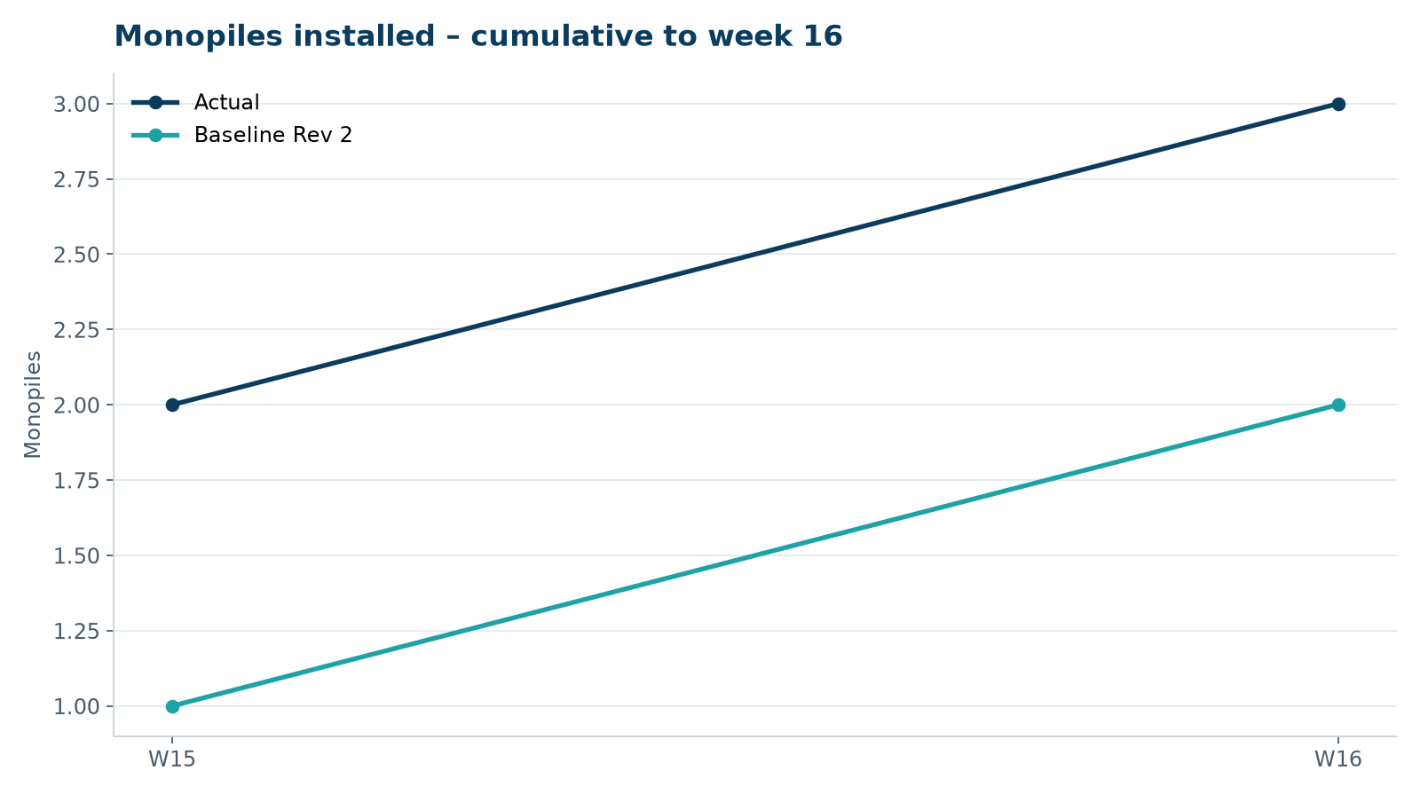
Figure 1 – Monopile installation progress, W15 to W16

3. Key activities this week
- HB-A03 installed on 18 April.
- 31 hours waiting on weather (significant wave height above the 2.5 m jacking limit on 15–16 April).
- Transition piece HB-A02 installed; OSS jacket fabrication reported complete at the fabrication yard.

4. Health and safety
No lost time injuries. 22 observation cards submitted; top theme: mooring line handling.

5. Environment
- HB-A03: peak 158.8 dB SEL at 750 m (compliant); pre-piling search clear, soft start on time.

6. Issues and risks
- HB-RISK-001 weather: 31 h downtime this week.

7. Look-ahead next week
Load-out of piles HB-A04 to HB-A06; install HB-A04.
Prepared by Project Controls (Gareth Lewis); approved by Elena Márquez. Distribution: project team, Steering Committee, Halden Turbine Systems, Lenders' Technical Adviser.

